  - Fall for Harry Anna, become a Sustaining Donor!
Holiday Isles 1912’s first ever PUMPKIN COOK-OFF!
  - DATE: Sunday, October 9, 2022 TIME: 10:00 am – Noon
- Sign up as a Sustaining Donor starting at 10:00 am.
- Make anything PUMPKIN, let’s be creative!
- Bring your favorite pumpkin dish to share.
- All Current and NEW Sustaining Donors will be entered into a drawing for a special mystery prize!
- If you bring a dish to share, your tasting is free!
- As a sustaining donor- your tasting is free!
- All who are not sustaining donors will pay a fee of $5.00 for the tasting!
- YOU ARE THE JUDGE-all those who taste will choose their favorite dish to determine the winner of the competition.
- Have your sharable dish at the Lodge no later than 10:40 am, the tasting will start at 11:00 am.
- Drawing will be held at Noon.
OUR LODGE HAS A GOAL TO SIGN UP AS MANY NEW SUSTAINING DONORS AS POSSIBLE. WE WANT TO HAVE THE HIGHEST NUMBER OF DONORS IN OUR DISTRICT. PLEASE COME HELP US RAISE MONEY, EAT GOOD FOOD AND HAVE SOME FUN. Any monthly amount you have as a direct debit counts as being a sustaining donor. So, please come out, sign up to be a sustaining donor and help Our Lodge meet or exceed our goals.
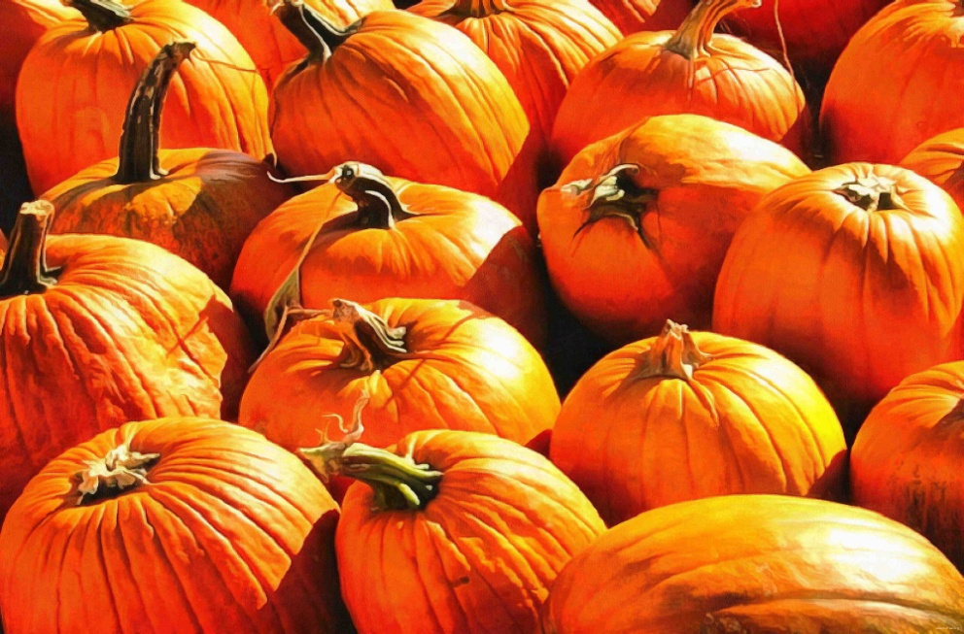
Any questions please call: Renee Singer (727) 772-3989 Or Sheila Tortorigi (860) 705-2768
  - ALL PROCEEDS SUPPORT HARRY ANNA TRUST FUND.

